**Temple Fair Fishing**

(Game Design Document)

**Table of Contents**

Game Overview

1. **Concept 1**
2. **Genre 1**

Visual

1. **Genre 1**
2. **Game Art 1**
3. **Who would want to play it 1**
4. **How it is like other games 1**
5. **How it is different 1**

Gameplay

1. **Mechanics 2**
2. **Goal 2**
3. **How players progress through the game 2**
4. **Rules 2**
5. **Stages for the Paper Scooper 3**
6. **Flowchart 3**

Gameworld

1. **Setting 3**
2. **What each level would be like 3**
3. **Drawings**
   1. **Start Screen 4**
   2. **Levels 5**

Characters

1. **Main character PC 6**
2. **Enemies NPC 6**
3. **Bosses? 6**
4. **Look/ Move/ Strengths/ Weaknesses 6**

**Overview**

**Concept**

You are playing as someone who is at a temple fair playing the fishing game. There will be a pool with fish swimming in it. You have a bucket and a scooper made from paper. Your job is to catch enough fish before your paper scooper tears

**Visual**

**Genre**

Temple fair fishing is a casual type of game, meaning that it does not require any long-term time commitment, or special skills of some sort.

**Game Art**

The art style will be cartoony, with little to no shading.

**Who would want to play it**

This game might interest Achievers (people who likes achieving goals and collecting things.)

you earn points by catching fish.

**How it is like other games**

Like other types of casual games, Temple Fair Fishing has a simple gameplay. Each level requires a short amount of time to accomplish, and you don’t need to save the game.

**How it is different**

Temple Fair Fishing is a fishing game, but unlike other fishing games, you are given a paper scooper instead of a fishing rod.

**Gameplay**

**Mechanics**

The movement of the paper scooper is going to be controlled by arrow keys / mouse

To dip the scooper into the water, either press spacebar or left click on the mouse.

**Goal**

The goal of this game is to get as much fish in the bucket as you can before your paper scooper tears completely. By putting fish in the bucket, you earn points. If you earn enough points, you get to move to the next level.

**How players progress through the game**

In this game, the player progresses by reaching the next level. In each level, there will be a target amount of points you need to reach. You earn points by putting fish in the bucket. Different fish gives you different points.

**Rules**

* There will be 5 levels in the game
* A player will be given a paper scooper/scoopers for each level
* Player must catch fish and put in the bucket to earn points
* Reach the next level by reaching the target point/ amount of fish.
* In each level, there are several kinds of fish. You get extra points by scooping faster/bigger fish.
* Each level will make you scoop more fish
* A new kind of fish will be added to most of the levels. (not in levels 3 and 5)
* The paper scooper will go through 5 stages of tearing until it tears completely.

***Further challenges***

As you move to higher levels, you must scoop more fish. Your scooper will break by the time you caught all the fish if you were to catch a fish per scoop. So, player must get multiple fish in one scoop and put in the bucket.

**Stages for the Paper Scooper**

There will be 5 stages for your paper scooper. Each stage controls the condition of the scooper and how it looks. For example, at first, your scooper will be fully intact with the paper part still dry. As you leave the paper underwater for more than 10 seconds, it will become slightly darker. If you leave it for another 6 second, it will become even darker. The paper scooper will gradually get darker until it starts to tear and break.

**Scooper 🡪 Water Rule Flowchart**

1. 10 sec – slightly darker

**Start**

Read Mission

1. 6- sec- a little darker
2. 4 sec- darker
3. 3 sec– starts to tear

Scoop Fish

1. 4 sec – starts to tear even more
2. Breaks once you scoop fish

Yes

Is the scooper still intact?

No

No

Yes

Did you catch enough fish?

Go to next level

**Gameworld**

**Setting**

Temple fair fishing is a top down fishing game. The setting revolves around a fish pool. It will take place at night. (just like how it is at a real temple fair) The pool will take up most of the space in the game’s layout. The fish bucket will be placed either on the lower left part of the screen, or at the center of the fish pool. The bucket will display the fish you’ve caught. (the fish will be swimming inside your fish bucket)

**What each level would be like**

The layout of each level will look the same. (Each having a pool, fish in the pool, a mission board that tells you what to do, 1 bucket, and at least a paper scooper.)

**Level 1** is a normal fishing level, meaning that there is no time pressure. This level will have 3 different kinds of fish, each fish appearing shortly after the previous one.

*Objective = Earn 20 pts.

Fish #1 🡪 +1pt.

Fish #2 🡪 +1pt.

Fish #3 🡪 +2pts.

**Level 2** is also a normal fishing level. This level will have 4 kinds of fish, with the 4th one appearing after the third one appears. The first three fish will appear after each other faster in this level than the first level.

*Objective = Earn 30 pts.

Fish #4 🡪 +2pts.

**Level 3** will be a timed level. There will be a count down from 40 seconds. The mission board will also tell how many fish player must catch/ how many player have caught. The kinds of fish in level 3 will be the same as in level 2

*Objective = catch 40 fish

**Level 4** is a normal fishing level, like in levels 1 and 2. Sting rays will be added in this level. They will appear in the beginning of this level.

*Objective = Earn 40 pts.

Sting ray 🡪 +5pts.

**Level 5** will be the boss level. Unlike the first 4 levels, you will be given 3 paper scoopers, player will have to catch all fish. In this level, there will be 3 types of fish. 2 kinds of 1 point fish (there will be 20 of them), and baby sting rays. (there will be 2 of them)

**Drawings**

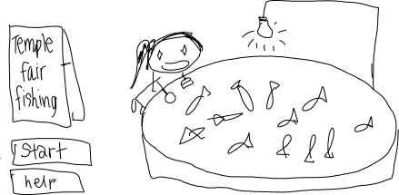

***Start Page***

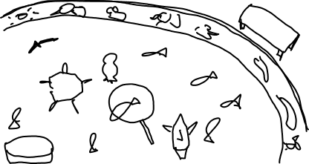

***Level Layout Style 01***

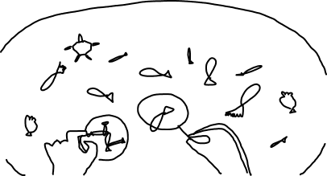

***Level Layout Style 02***

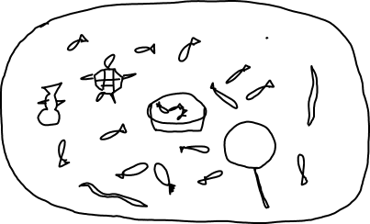

***Level Layout Style 03***

**Characters**

**Main Character PC**

You will be controlling the paper scooper.

**Enemies/ NPC**

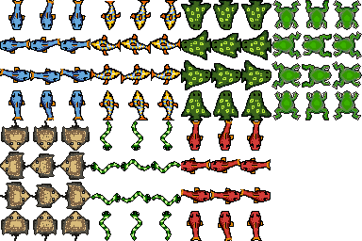Non-playable characters will be the fish. They will swim around

**Bosses**

Bosses will be the baby sting rays. Your scooper easily breaks when player scoops up sting rays. Although it is possible to do it when you go for the middle.

**Look/ Move/ Strengths/ Weaknesses**

Look - Your character will look like an ordinary paper scooper, but the paper part of it will change in accordance to how often you dip it into the fish pool/ leave it in there/ scoop fish. Strength - it scoops up fish. Weaknesses - It starts to rip the more you put it in the water/leave it in there.